CHAPTER III

FORMS AND DATA ANALYSIS

This chapter contains the form description, data analysis and data dictionary. In this chapter, forms that are used in the company are being described. The form description talks about the purposes of the forms, its frequency of use and its distribution scheme. Data analysis includes findings of what causes the problem to exist in the processing of transactions and how it is solved. This also includes the Entity Relationship Diagram (ERD) that shows the information use by the system and its relationship with other data. The data dictionary contains description of tables and data fields.

3.1 Form Description

The forms that are utilized by the company in the processing of transactions are discussed in this section of the document. This includes the description and explanation of the forms that are collected from the company during the gathering of data. This also discusses the form layouts description, its purposes and how it is used and implemented in the transactions of the company. The employee’s in-charge in the preparation, organization, generation of the forms and the form recipient are also included. There are various forms that the company utilized. These are the: student application form, acknowledgment receipt, applicant’s information sheet, certificate of enrollment, offer letter, and the approve letter.

Figure 14 is the applicant’s information sheet; this form be filled-out by the student or the tourist once they wanted to apply for a student visa or for the tourist visa. This form consists the personal details of the applicant, passport details, photo of the applicant. Once this form is filled-out the clients need to pass the needed requirements for visa application. The consultant checks the requirements, verify it, forward it to the embassy and the client now wait for the visa status.

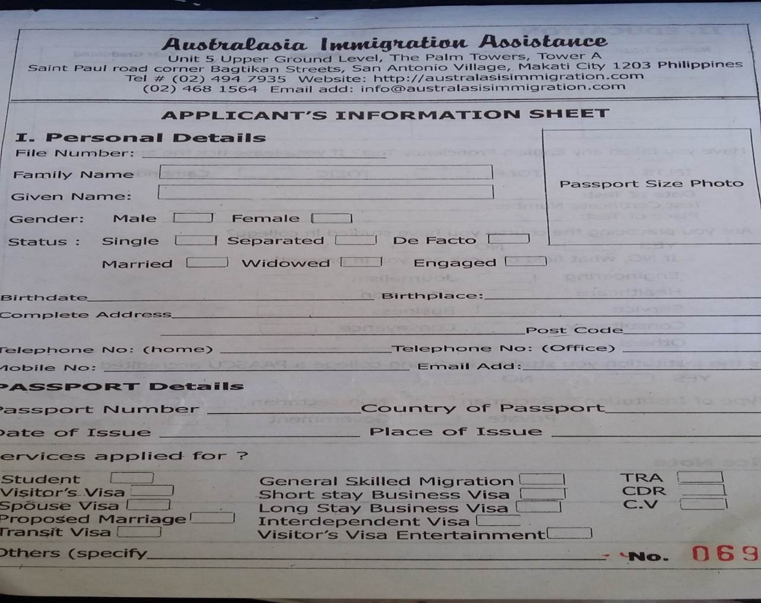

Figure 14. Applicant’s Information Sheet.

Figure 15 is the student visa application form. This form is used for student who wanted to apply to migrate abroad for school purposes. In this form, general information about the students be seen. Once the consultant fills out the Applicant’s Information Sheet. After matching process this form was the next to fill-up. This form only be applicable for students who are planning to go to school abroad.

Figure 15. Student Visa Application Form.

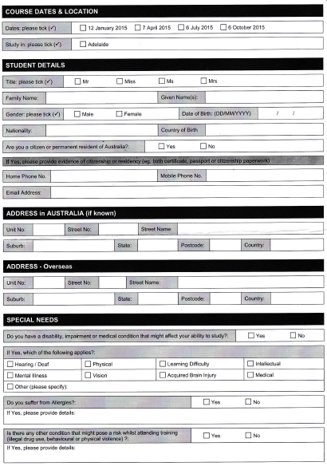

The IELTS Test Results Form which shows in the Figure 16 is the results of those clients who pass or fails their IELTS exams. The admin provides an examination sheet for those clients who wants to study abroad. The clients must first fill in all the fields required including the student’s full name, the center number, date, candidate number, passport photo, date of birth, gender, scheme code, nationality and the first language that the client’s spoken. After taking the exam, the client results must be informed by the admin.

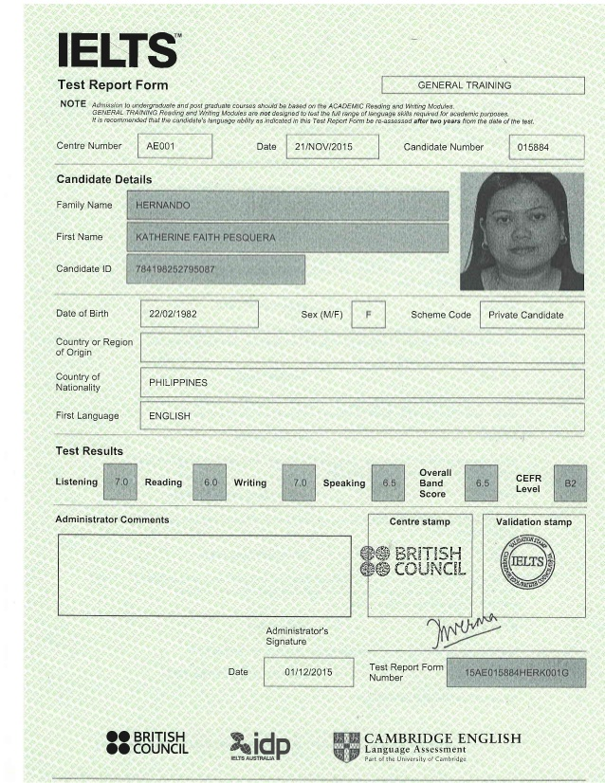

PASSPORT PHOTO

Figure 16. IELTS Test Result.

The NBI Clearance which shows in the Figure 17 is one of the very important requirement needed to travel and study abroad. The clients must have an updated NBI Clearance as a proof of not having a stained criminal records. The NBI Clearance is also a valid requirement in applying purposes for it is a government issued and it is easy to obtain.

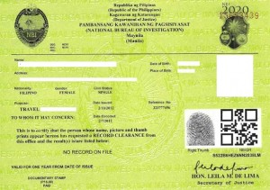

Figure 17. NBI Clearance.

Figure 18 shows the certification of live birth as required for both students and tourist in applying abroad. It is needed upon application as one of the major records for the company to have an actual record of birth of their clients. The certificate of live birth must be NSO copied upon submission.

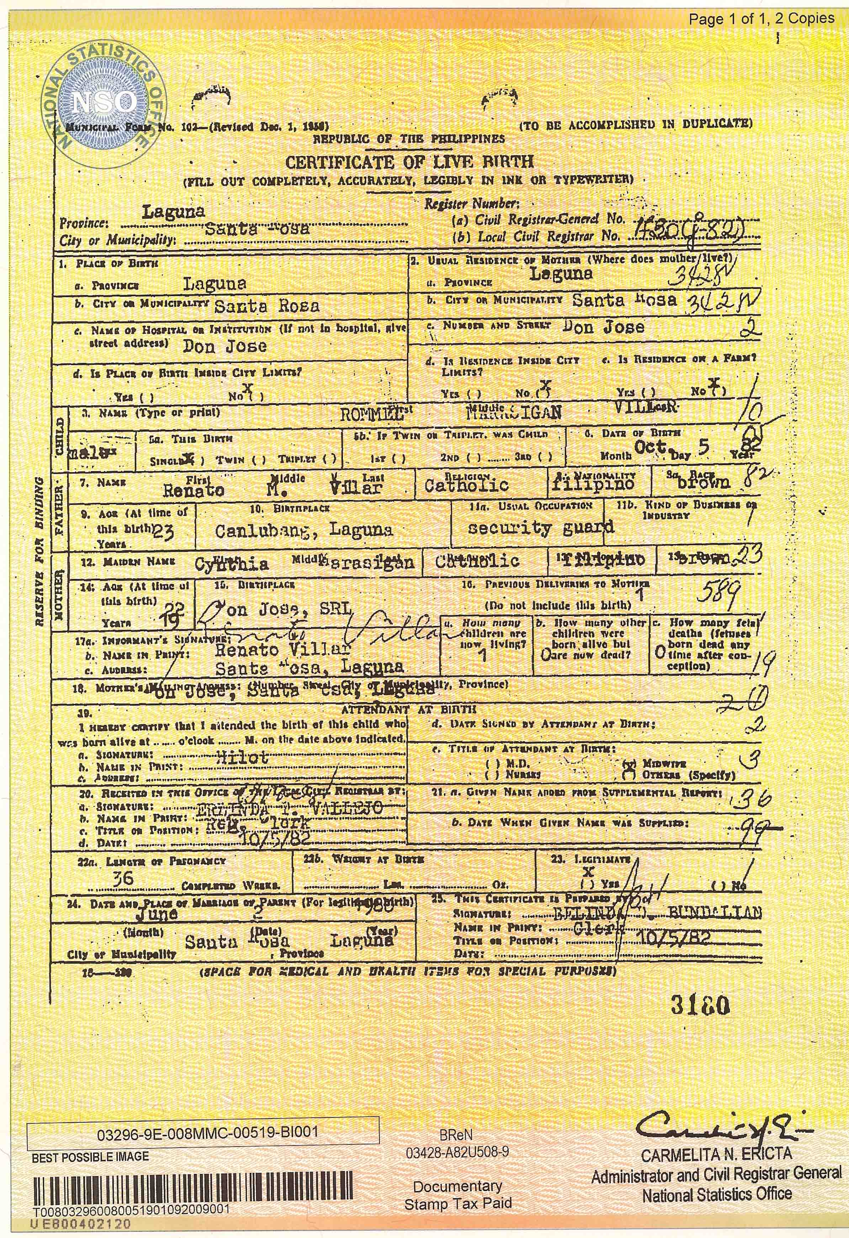

Figure 18. Certificate of Live Birth.

Figure 19 is the offer letter; just like the certificate of enrollment this form comes from the school to be given to the organization. This form state that the application for a student vocational education and training section visa of a specific student is now granted. The letter be addressed to the organization specifically to the Manager.

This form contains the information of the student, the Application ID and the Grant ID which is given by the school. This form is important because it is like an agreement between the student and the school.

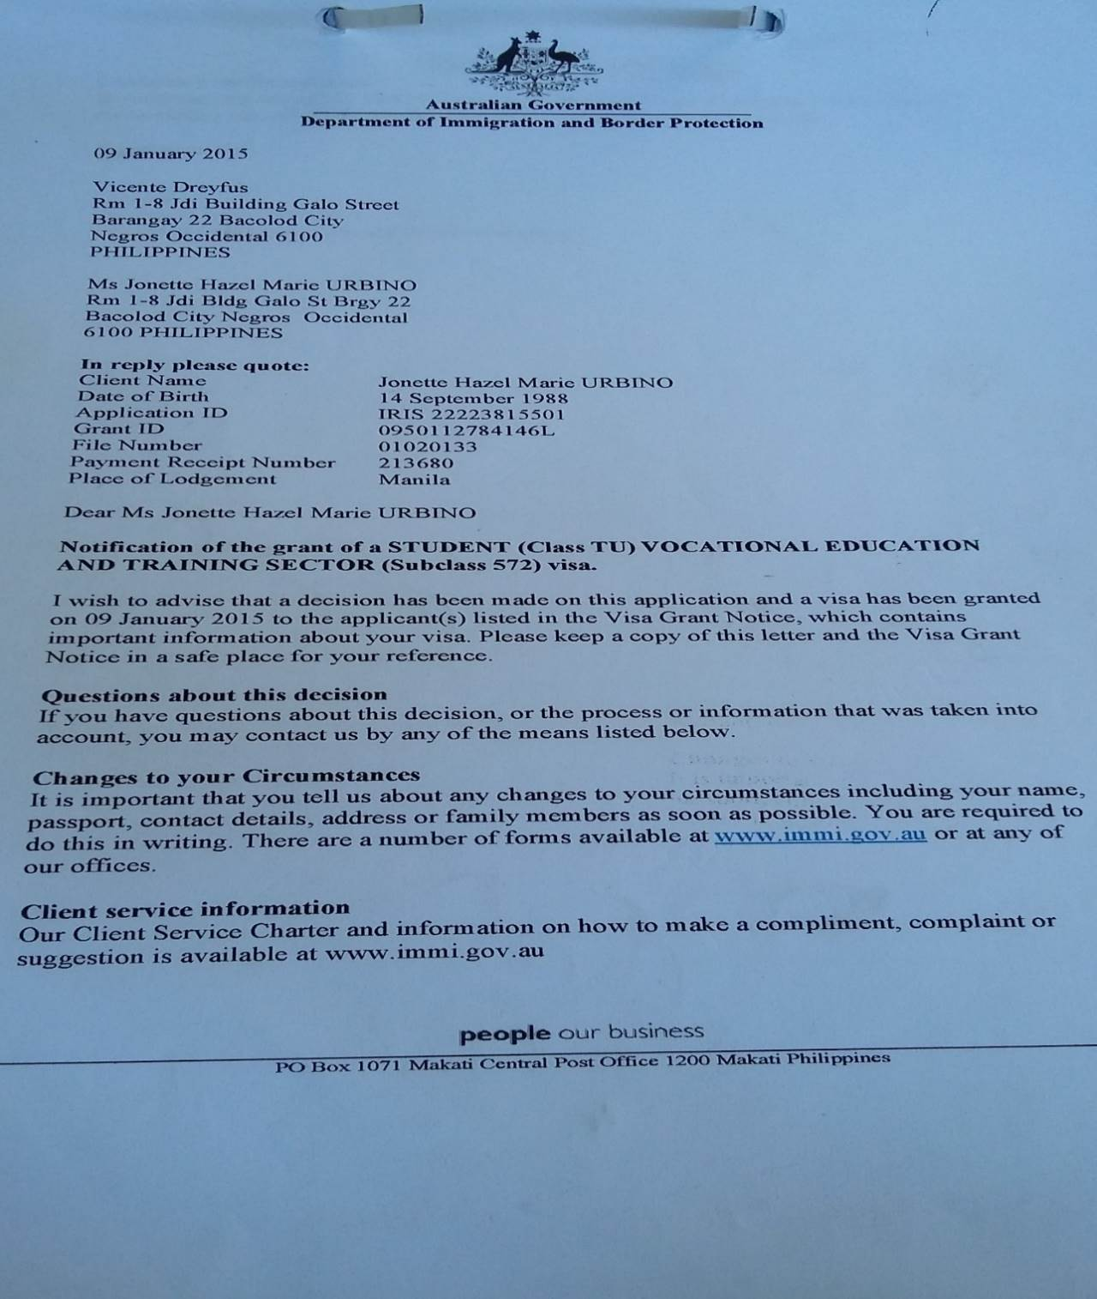

Figure 19. Offer Letter.

Figure 20 is the certificate of enrollment or the confirmation-of-enrollment (CoE). This form be the confirmation of the school abroad if they wanted a student to apply for their school or not. This form be received by the organization from the different schools abroad, particularly on Australia, New Zealand, and Canada. This form is given to students once the school confirms the enrollment of the specific student and the program of study that student enroll to.

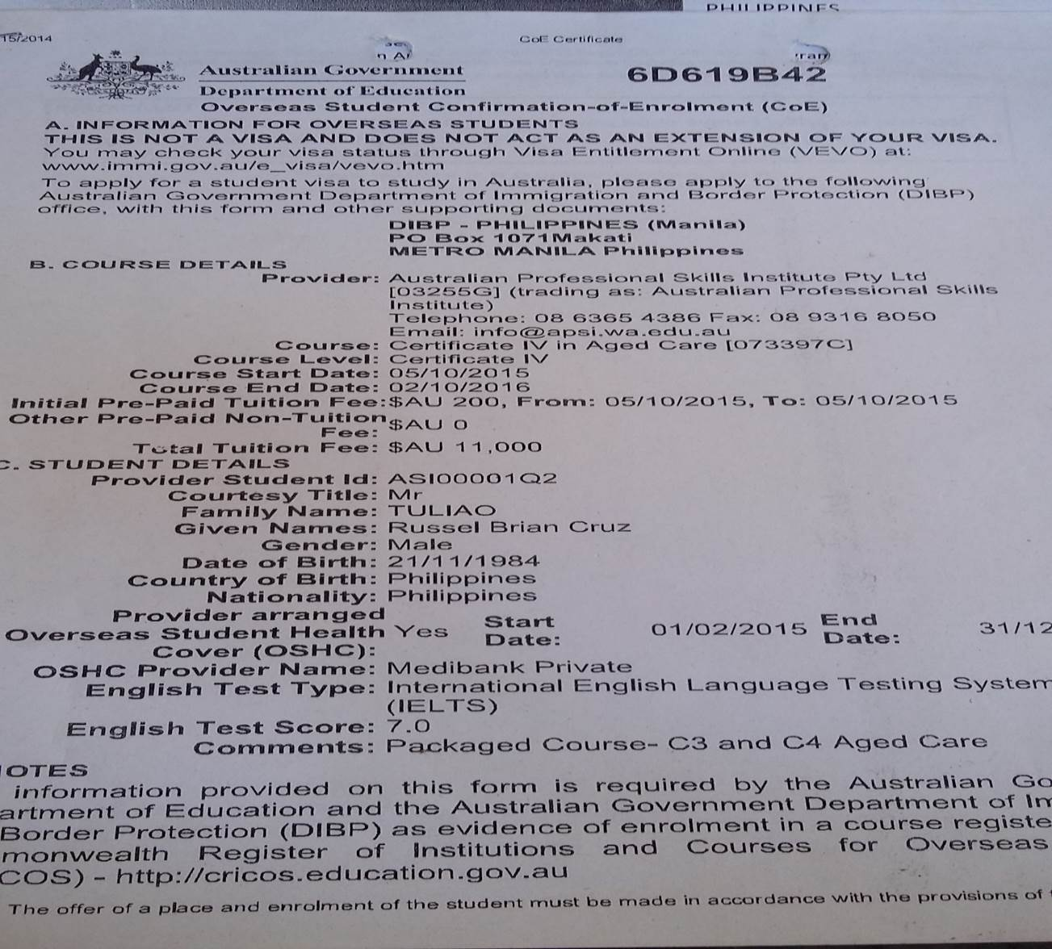

Figure 20. Certificate of Enrollment.

3.2 Data Analysis

This section ensures that all details and use data are captured in the formal enterprise model. Also, it shows the functionality of the entities in the system. The diagrams help focus on how database works. ERD shows entities in a database and relationships between tables within the database.

The ERD contains fourteen tables which contains different kinds of entities. Entities in this database is necessary because it contain different information needed for the system to process transactions correctly and effectively.

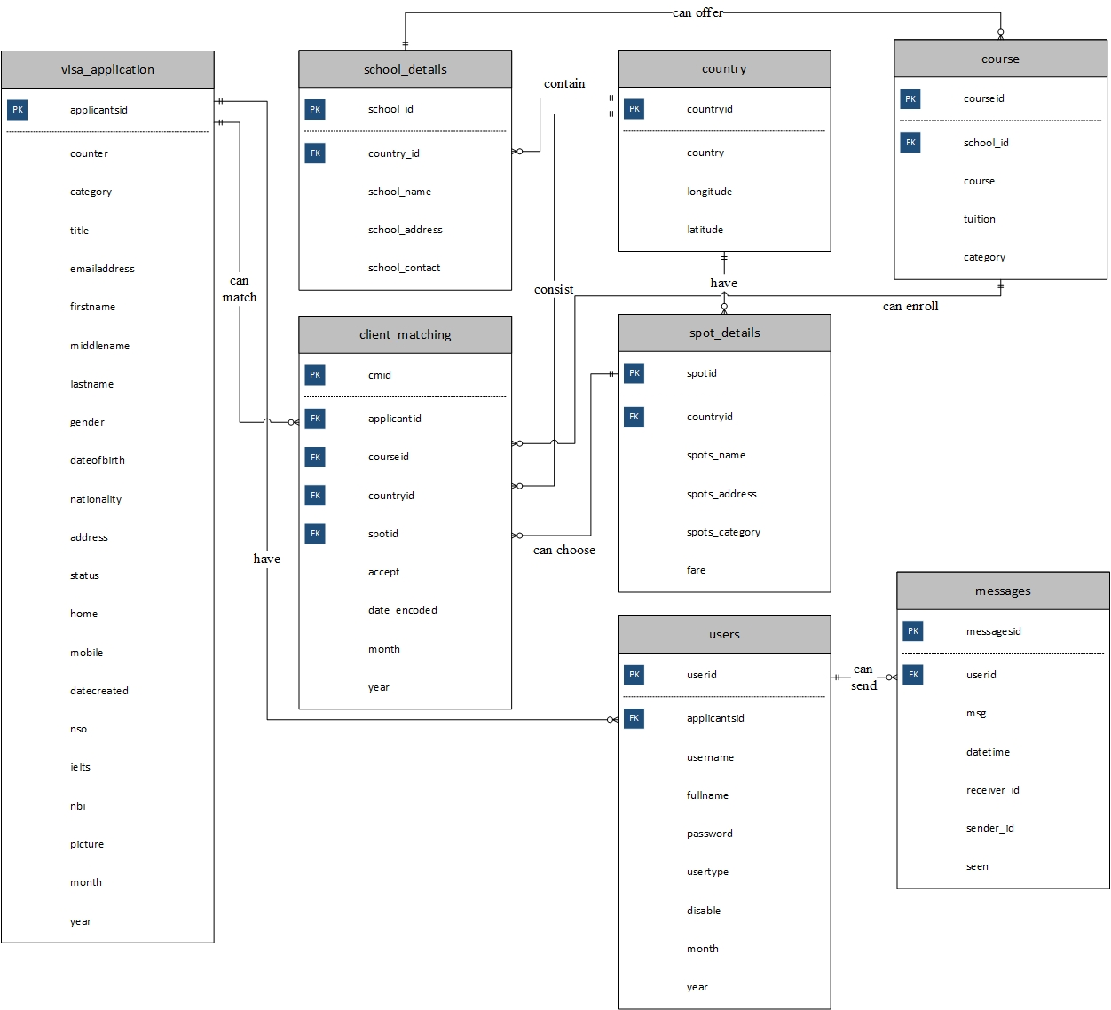

Figure 19. Entity-Relationship Diagram of Inter-Pacific Study and Migration Consultancy.

3.3 Data Dictionary

The data dictionary is an important element of the database for it provides information about a database and the information that it contains. The primary key and foreign key are included for the consistency of the database. This is for the benefit of the computer operator as the guide and basis in analyzing the objects or the data.

Table 1 is all about messages. This table serve as storage of messages that is used in our monitoring of clients. All the conversation that been send and receive by both users save in this database. Base on the given description in the table it helps the reader to understand what the purpose of the given field name in the table.

|  |  |  |  |  |
| --- | --- | --- | --- | --- |
| Field Name | Description | Type | Length | Format |
| messagesid | Message personal ID number | int | 11 | 1(11) |
| userid | ID number of the user | int | 11 | 1(11) |
| msg | Message content | text | 255 | A(255) |
| datetime | Time-stamps for messages | datetime | 8 | MM-DD-YYYY |
| sender_id | ID number of the sender | int | 11 | 1(11) |
| receiver_id | ID number of the receiver | int | 11 | 1(11) |
| Seen | One if the user seen the message and zero if not | int | 11 | 1(11) |

Table 1. messages.

Table 2 is the adding programs. This table serves as a storage for all the new programs being offered by a certain school or university. Each entity has their specific description so that it is easy to understand.

|  |  |  |  |  |
| --- | --- | --- | --- | --- |
| Field Name | Description | Type | Length | Format |
| courseid | Course personal ID | int | 3 | 1(3) |
| course | Name of the course | C | 255 | A(255) |
| school_id | ID of the School | int | 3 | 1(3) |
| tuition | Tuition of the Program | int | 11 | 1(11) |
| category | Category of the different courses | C | 100 | A(100) |

Table 2. courses.

Table 3 is the Country. This table is the storage of all the countries the company is associated to. The table is consisting of two entities, the primary key for a certain country, and the name of the country.

|  |  |  |  |  |
| --- | --- | --- | --- | --- |
| Field Name | Description | Type | Length | Format |
| countryid | Country personal ID | int | 12 | 1(12) |
| country | Name of the country | C | 15 | A(15) |
| longitude | Longitude of the country | C | 20 | A(20) |
| latitude | Latitude of the country | C | 20 | A(20) |

Table 3. Country

Table 4 is the school_details. This table is used as storage for all the partner school of the company outside the Philippines. Those data that been input in the adding school module save in this table. This table show the description and the type of each entity that been used.

|  |  |  |  |  |
| --- | --- | --- | --- | --- |
| Field Name | Description | Type | Length | Format |
| school_id | School personal ID | int | 3 | 1(3) |
| school_name | Name of the school | C | 50 | A(50) |
| school_address | Address of the school | C | 150 | A(150) |
| country_id | Country the school is located | int | 15 | 1(15) |
| school_contact | Contact number of the school | C | 15 | A(15) |

Table 4. school_details.

Table 5 is the student_school_matching. This database is used to save the data after attempting the matching feature of the system. This table is used as storage for all the clients that attempts the matching features of the system.

|  |  |  |  |  |
| --- | --- | --- | --- | --- |
| Field Name | Description | Type | Length | Format |
| cmid | School personal ID | int | 11 | 1(11) |
| applicant_id | Client personal ID | int | 50 | 1(50) |
| course_id | Program personal ID | int | 150 | 1(150) |
| spotid | Spots personal ID | int | 15 | 1(15) |
| countryid | Country personal ID | int | 15 | 1(15) |
| date_encoded | Date of the data encoded | timestamp | 14 | MM-DD-YYYY |
| accept | One if the admin accepts it and zero if not yet | int | 1 | 1(1) |
| month | Month of the data encoded for report purposes | C | 3 | A(3) |
| year | Year of the data encoded for report purposes | C | 4 | A(4) |

Table 5. client_matching.

Table 6 is the tourist_matching. This table is the basis of the matching feature of the system for tourist category. All data that stored in this database show in the system if the client (Tourist) attempt for matching.

|  |  |  |  |  |
| --- | --- | --- | --- | --- |
| Field Name | Description | Type | Length | Format |
| SpotID | Tourist spot personal ID | int | 3 | 1(3) |
| Spots_Name | Name of the tourist spot | C | 50 | A(50) |
| Spots_Address | Address of the tourist spot | C | 100 | A(100) |
| Spots_Category | Category to where it belongs | C | 15 | A(15) |
| CountryID | Country personal ID | int | 11 | 1(11) |
| fare | Fare of the places | int | 11 | 1(11) |

Table 6. spot_details.

Table 7 is the visa_application. This table is use as the storage of different client of the system once they complete applying for visa. It also shows the different entities use with their specific description and type. These entities used in making different queries in the program.

|  |  |  |  |  |
| --- | --- | --- | --- | --- |
| Field Name | Description | Type | Length | Format |
| applicantsid | Unique client ID | text | 100 | A(100) |
| counter | It helps the applicantsid become unique | int | 11 | 1(11) |
| category | Client category | C | 10 | A(10) |
| title | Client title | C | 5 | A(5) |
| firstname | Client firstname | C | 30 | A(30) |
| middlename | Client middlename | C | 15 | A(15) |
| lastname | Client lastname | C | 30 | A(30) |
| gender | Client gender | C | 10 | A(10) |
| dateofbirth | Client birthday | date | 8 | MM-DD-YYYY |
| nationality | Client nationality | C | 20 | A(20) |
| address | Client address | C | 150 | A(150) |
| home | Client home number | C | 10 | A(10) |
| mobile | Client mobile number | C | 12 | A(12) |
| emailaddress | Client email address | C | 60 | A(60) |
| status | Client status | C | 30 | A(30) |
| datecreated | Date encoded | date | 8 | MM-DD-YYYY |
| nso | Client nso file | text | 100 | A(100) |
| ielts | Client ielts file | text | 100 | A(100) |
| nbi | Client nbi file | text | 100 | A(100) |
| picture | Client picture file | text | 100 | A(100) |
| month | Month of the visa application encoded for report purposes | C | 3 | A(3) |
| year | Year of the visa application encoded for report purposes | C | 4 | A(4) |

Table 7. visa_application.

Table 8 is the users. This table is use as the storage of different users of the system once they complete the registration. It also shows the different entities use with their specific description and type. This entity used in making different queries in the program.

|  |  |  |  |  |
| --- | --- | --- | --- | --- |
| Field Name | Description | Type | Length | Format |
| userid | User personal ID | int | 11 | 9(11) |
| fullname | Users full name | C | 100 | A(100) |
| username | Username of the user | C | 20 | A(20) |
| password | Password of the user | C | 20 | A(20) |
| usertype | Type of user | C | 10 | A(10) |
| disable | One represents for disable and zero for enable | int | 11 | 1(11) |
| applicantsid | Client unique ID | text | 255 | A(255) |
| month | Month of the user encoded for report purposes | C | 3 | A(3) |
| year | Year of the user encoded for report purposes | C | 4 | A(4) |

Table 8. users.

In this chapter, the team had presented all the data that has been used as bases to the development of the system. Starting from the forms used by company, to the ERD for the processes and relationship of each functions, and the data dictionary. These records are important so that the team could analyze what necessary information must be included in the system. This also, allows the team to create familiar words and processes to the user that they usually operate.